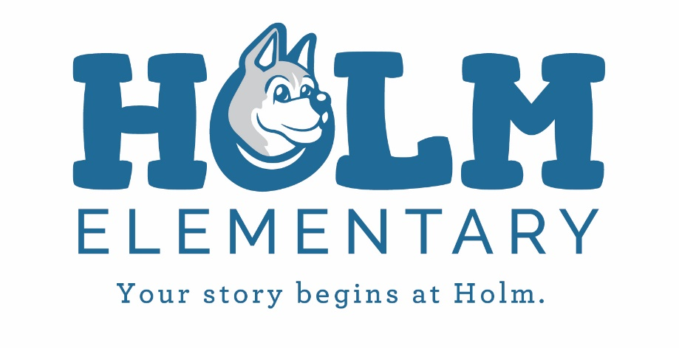
Spirit Day

The LAST Spirit Day of the school year will be held on Friday, May 25, 2018. We will be giving awards for and talking about Growth Mindset.

The themes for the week will be:
Monday- Mismatch
Tuesday- 80’s, or Decade Day
Wednesday- Pajama day
Thursday- Dress for Success day
Friday- Wear your Holm white and blue!

The assembly times are listed below:
2nd | 8:20-8:50
5th | 9-9:40
4th and MIS | 11-11:40
ECE/K | 11:50-12:30
1st | 1:20-1:50
3rd | 2-2:45

